**TestNG**

1. Annotations with Order of Execution of Annotation
2. Setting Priority
3. Ignore Test case
4. Thread pool Size
5. Running Test case multiple times
6. Create Groups
7. Parameter passing (XML)
8. Parameter passing using Data Provider
9. Handle Exceptions
10. Method dependency
11. Group dependency
12. Timeout
13. Soft Assertion
14. Parallel Execution
15. Listeners

**TestNG Video-1**

TestNG?

DEPENDACY AND Plugin IN DIFFERENT ?

Maven project use pandrom na -- dependency add pannuvom.

Java project use pandrom na -- .Jar file ah add pannuvom.

Plugin -- Software or tools nu sollalam

Dependacy -- na oru libraries or .jar file nu sollalam.

**njhlh;r;rpahd- Sequential Execution Video-2**

**Sequential Execution** == 4,5 Set case ah at the time onna run pandrathu..

* TestNG ah run panna normal main method iruka koodathu.. simple la normal method la irunthu run pannalam.
* “Main method” iruntha TestNG la one by one program ah than run panna mudiyum sequential la program ah run panna mudiyathu..
* First test case execute ayi close ana apparam than Second test case execute pannum..
* Run as - TESTNG kudutha athu internal ah XML. File create ahgum.. so Xml file vachu than Test NG programe ah run pannum.

Main method ====> Normal Method ah convert pannanum..

* Public == irukalam
* Static == irukalam but Not recommed… Static ilamely run pannalam..
* Void == return type kanndippa irukanumm. Vera return type iruntha run agathu.. So must have “Void”
* Method name == class voda name recommeded ila. Any method name vachukalam.
* (String[]args) iruka kudathu..

**@Test annotation must**

* Method ku mela **@Test** nu annotation kudukanum… appidi kudutha than “Runas Testng test” nu varum.. ilana varathu.
* **@Test ==** potta than antha class ku XML file create aghum. @Test ah remove pannidu pannom na varathu.

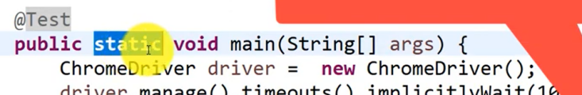

Intha mathiri Main method run panna kudathu.. [Run agathu error varum. “No Test Found Nothing was Running. ”] message varum. So main method ah remove pannanum.

“,ize;J“ --- **Parallel Run Video-3**

Parallel Run -- At the time la 2,3 browser orey nerathula open ayi ovaru test case ovaru browser la parallel la run aghum.

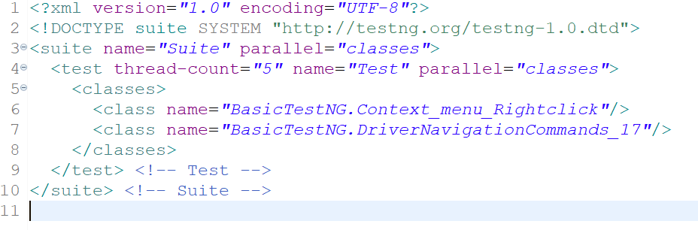

Thread-count= “5”

Thread count na no.of browser voda count ithu.. “5” na parellel la 5 browser at the time la 5 test script um at the timela run aghum..

So 5 thread create aghum. Inke xml voda count 2 than iruku and 2 thread la madum run ayidum. Balance 3 thread idle la than irukum..

Parallel = classes [method iruku & ]

Script class padi run aghum.. I mean First in First Out

Thread count = -1 kodutha === intha exception varum. [interview questions]

java.lang.IllegalArgumentException

Priority = Attributes **TestNG Attribute-1 Video-4**

**@Test = ndrathu annotation**

**( ) = ethavathu pass panna athu attribut nu solluvom.**

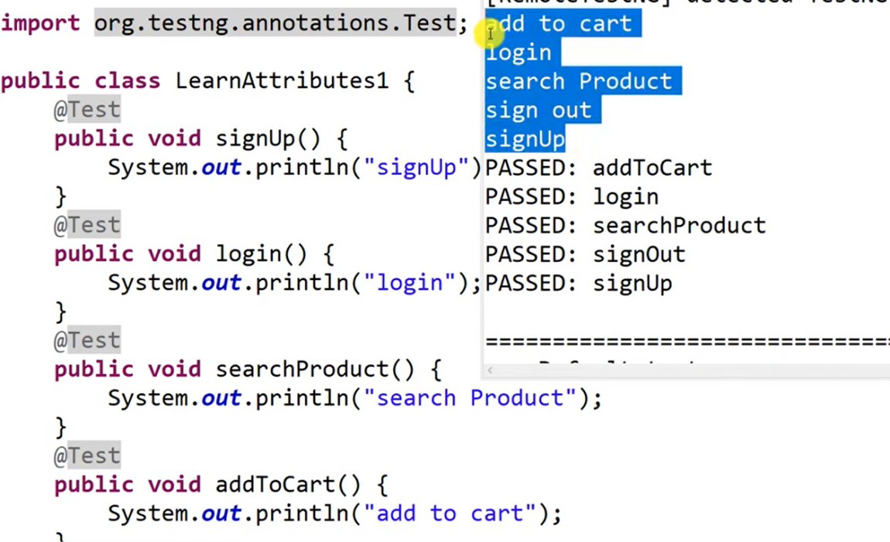

* + Ithu oru normal method ithuku @test annotation kuduthu testNG la run pandrom..

But output method la kudutha list of execution padi varala why?

* Yean na TestNg voda default execution ASCII key padi execution aghuthu.. A=65, a=97 intha mathiri
* ASCII padi paatha captial A than first run aghum.. lower case next run aghum..
* So ithu than TestNG voda default behaviour..

Intha behaviour ah change panna few method iruku athula onnu than intha priority method

Priority method @Test(priority = 1) priority method **int value** kudukanum..

Ippidi kudutha namma kudutha No.s padi execution nadakum.

@Test = Annotation

Priority = Attributes

Priority voda executions -1(minus) value iruntha athu than first execute aghum. Positive value apparam execute aghum.

Way of Execution

-4 -3 -2 -1 0 1 2 3 4 5

* @Test()== priority voda default value = 0
* Namma priority kudukama iruntha athu ZERO value ah consider pannikum.

**TestNG Attribute-2 (Dependson) = Video-5**

@Test(dependsOnMethod = “MethodName”)== inke method name ah pass pannanum.

Dependson Method ah use pannanum na orey class la irunthalum. [Pacakage name. className. methodName]

Ithuve different package, and different class irukura method access pannanaum na

**dependsOn = “Packagename.classname.method-name.”**

TestNg voda execution type ah change panna innoru method than despendsonmethod .

1. Priority
2. Dependsonmethod

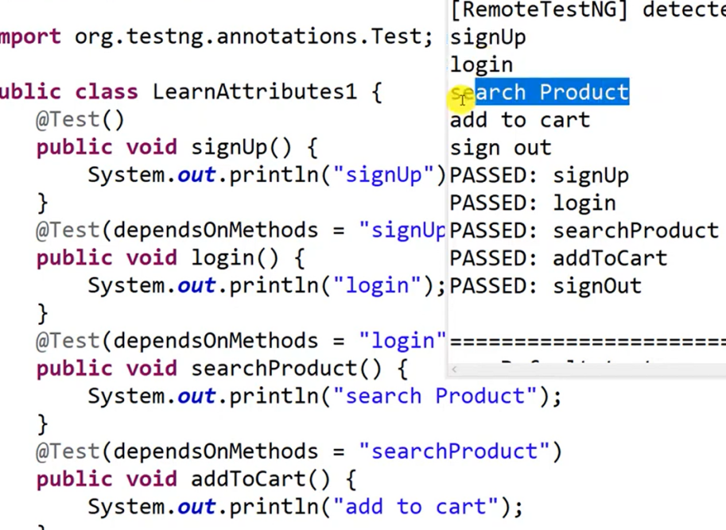

* **First method ku dependsonmethod No needed.** Yean na ithu innoru method **depend** panni ila..
* Other methods ellam depends panni irukum.

Oru dependson method fail ana enna aghum?

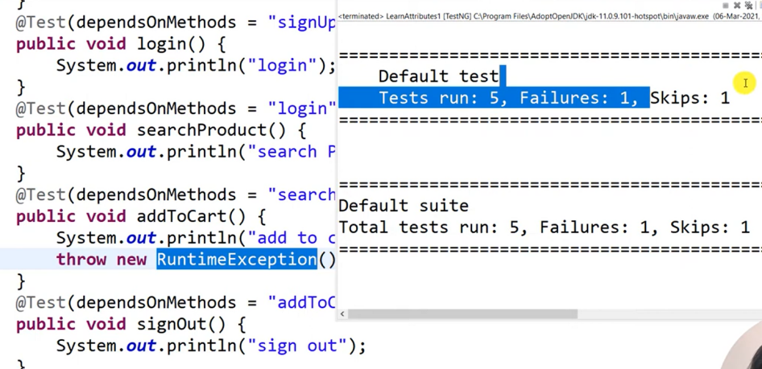Oru depends fail achuna Failure -1, skip-1 nu varum. (based on these case)

* Skip yean vanthurukkuna AddtoCart method fails ayiruchu.. so intha depends panni than signout method iruku.. athu than SKIPS nu varuthu. But TestNG itha execute pannirukaathu.
* Skip == problem ah handle panna kila innoru method iruku.[alwaysRun = true]

**dependsonMethods + priority = orey method la use pannalama?**

Yes pannalam, but dependsOnMethods ku than High priority irukum.

**(Dependson Method)**

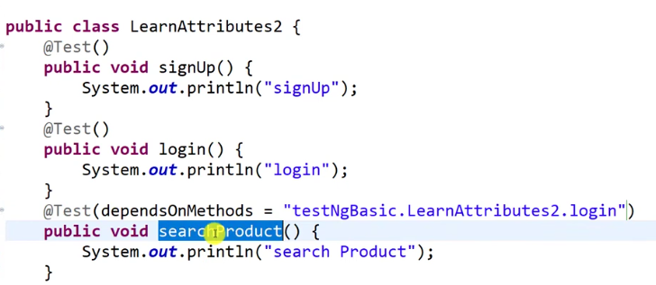

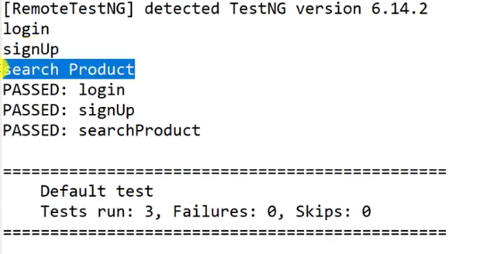

**TestNG Attribute-3 (Invocation count & invocation timeout) = Video-6**

Use: Oru test case many times run panni pakka for loops use pannvom.. But testNG la (miog;G;) invocation count = **Attribute (method ilai)** orey testcast ah neraya thadava run panni pakkalam loops use pannama..

test(InvocationCount = 2) ippidi kudutha test case 2 time run aghum.. ithula ‘int’ pass pannanum.

Invocation timeout la = long ah pass pannananum.

Innoru method iruku (InvocationTimeOut = 20000) ithu Invocation count iruntha madum than work aghum..

InvocationTimeOut = namma kuduthura time kulla antha Test Iteration run aganum. Ilana “Thread.Timeout.Exception” varum.

rg.testng.internal.thread.ThreadTimeoutException

**TestNG Attribute-3 (Always run, enable, description) = Video-6**

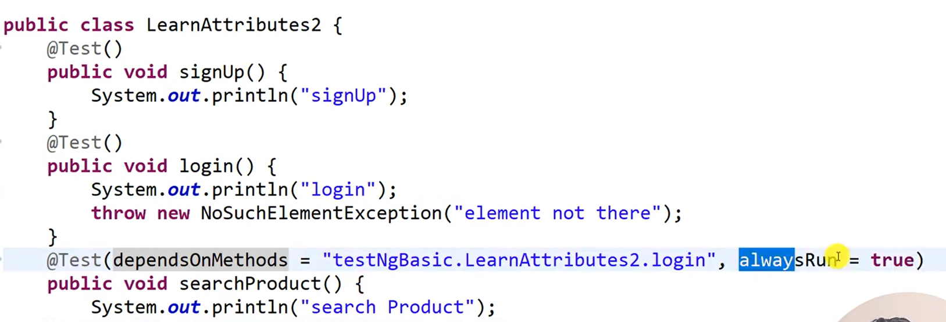

Orey class kulla irunthalum packagename. className.methodName kudukurathu best practise..

Mela ulla test case padi intension ah “**NoSuchElementException’** kuduthurukom athunala “**Searchproduct**” test case **SKIP** ayidum because ithu dependsonmethods la iruku.

* Console la == failure -1, Skip = 1 nu result varum. Skip ana test case execution kuda agathu..
* So intha overcome panna than **AlwaysRun** method use pandrom.. ithu dependson methods failure analum.. **alwaysrun** kudukura method run aghum. Skip agathu.
* **alwaysRun == method voda default value = false [true nu kodukanum.]**

**Enabled**

**Enable voda default value = true;**

So enable = false; kuduthurathu moolama oru test case run panna vidama pannalam..

I mean command panna mathiri act aghum.. ithuku command pannidalam.. irunthalum testNG la oru function ippidi kuduthurukanga..

Ex: namma oru thadava than signup pannaum 2 time poghum pothu login panna madum. Pothu. So signup case no need. In this time we use **enabled** function

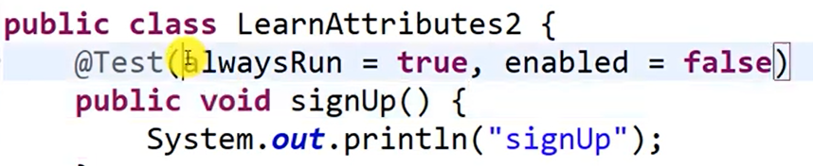

Intha mathiri 2 function um orey annotation la kudutha ena aghum? 2 mea oppsite methods..

**First priority Enabled = false function than**

**Intha test case run agathu.. and ithu oru test case ve consider pannaathu…**

**description**

@Test (description = "It will go to do signup function",

So intha mathiri antha test case pathi description write pannalam..

Ithu Console (Report) la print aghum..

**1.ThreadPoolsize, 2.Timeout & 3.ExceptedException**

1. threadpoolsize

**Ithuku invocationCount iruntha madum than ithu work aghum..**

invocationCount = 3 kudutha oru test case mudincha apparam innoru test case appidini 1 by 1 ah run aghum.. orey browserla

@Test(**invocationCount** = 2, threadPoolSize = 2)

Invocation timeout

Invocation count iruntha madum than work aghum.

So intha mathiri =2 kuduthom na 2 testcase 2 browser la at the time run aghum..

**Same ithuvum “Thread-Count” voda concept than**

**2.Timeout**

* Ithuku Invocation count Thevai ilai.. Separate ah run aghum.
* Ithuvum Timeout pola than.. Ana ithu Separate ah kuduthalum work aghum.
* Incase namma kudutha time la ithu work agalana

@Test(timeOut = 19000) likethis

rg.testng.internal.thread.ThreadTimeoutException----> Intha exception varum.

Same exception InvocationTimeoutlayum varuthu.

Ithu enka use pannuvom na… examples----

Firstly oru build mudinchu oru homepage open aganum na itha use pannalam.. I mean intha timinging kulla antha home page open aganum.. so intha test case TimeOut use pannalam.

1. **ExceptedException**

Varra error marachu test case ah run pandrathu..

Test case la ethavathu oru error varum pothu atha ignore panni test case ah failure aga vidama pandrathu..

@Test(expectedExceptions = {NoSuchElementException.**class**})

Ena error varra mathiri iruko antha error innke pass pannanm.. then. .**class** kandippa kodukanum.

**Groups**

5 = test case iruku.. 5 me run aga venndam.. 2/5 test case madum run aganum na 2 option iruku

1. Group.
2. Pacakage.

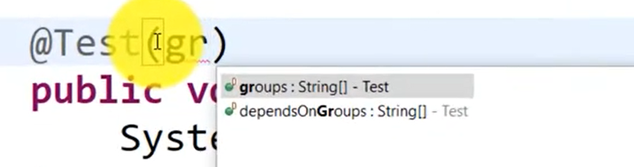

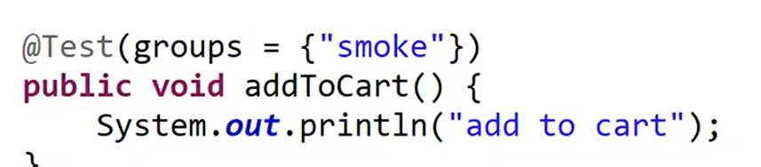

“Name use pannaikanum.”

<include name = “smoke”></include>

intha name than inke pass pannanum.

Groups == String[] array --- appidina inthula multiple value pass pannalam nu meaning.

Value ah String ah pass pannanum.

Test case ah group panna XML vachu than pannamudiyum..

Oru class ulla test case nu ilama different class la ulla test case um run pannalam..

XML la convert pannirukanum.

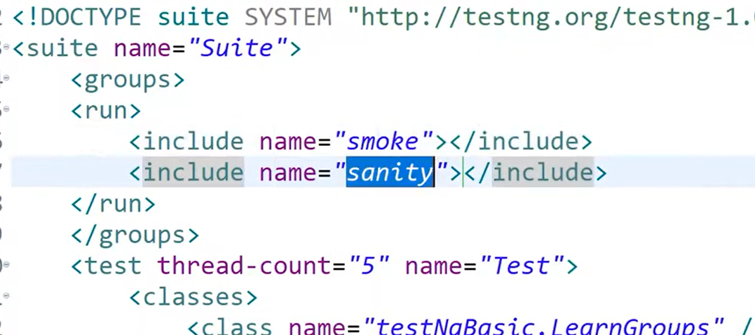

Test case ku xml file create panni

**<suite ……………….suite>**

Kila **groups** ah create pannanum. Then **run** create pannanum..

Then namma commands “**Include and exclude”** ah whatever I want will do it.

Include == Nrh;j;J

include la kudukurathu groups name ellame run aghum..

Exclude == jtpu

T exclude la kudukura groups name ethuve run agathu.. I mean athu thavirra balance ellame run aghum…

Include and exclude 2 mea onna kudutha ena aghu?

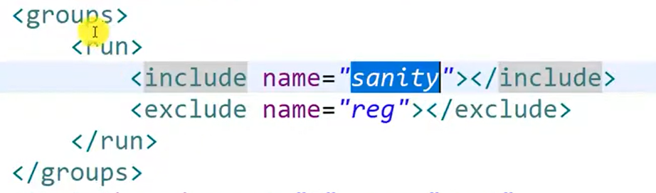

ANS:- Include la ena testcase iruko athu madum than run aghum.. Yena na “Include ” ku inke high priority….

Include and exclude la same name ah pass panna ena aghum?

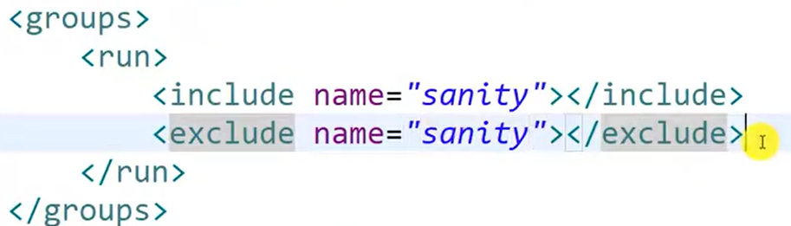

* Entha test case me Run agathu..
* 2 mea some ah kuduthum pothu exclude ku than high pirority irukum.

Multiple groups kudutha ena aghum. Nu pakkanum. To do

**Parameter**

work class name----> public class swabLap {

@ = pottu ethavathu varuthunna athu “Annonation nu ” Sollvom.

Athuve ( ) = kulla ethavathu vantha athuku name [Attribute]

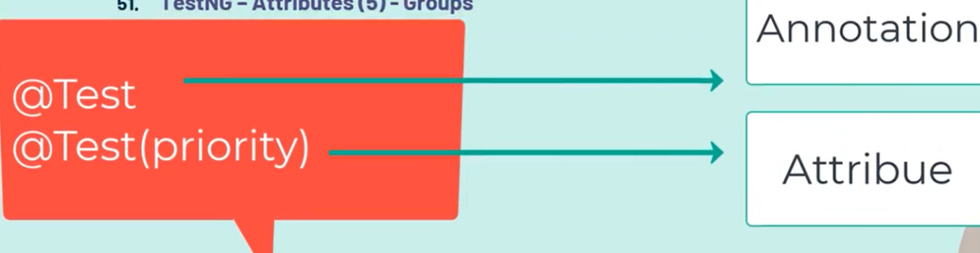

Parameters ah “Suite” levelayum and “Test” level layum kodukalam.

Generala Static data va madum parameter use panni pass panalam.. Broswer name, Admin voda login details.

Ithuve dinamic ah value pass pannanum na == Data provider use pannalam.

**Parameter in details**

Oru XML file kulla Oru “**Suite**” than irukum antha Suite kulla “**Test**” neraya irukum.

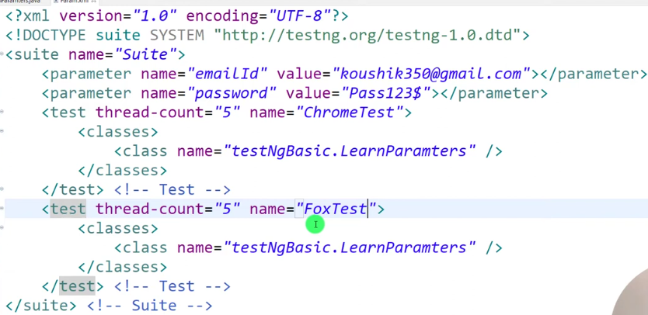

But Test voda name different ah irukanum..

Interview question:

Parameter ah vachi Cross browser testing eppudi pannuvanga nu keppanga..

Cross browser na Same testcase ah multiple browser la run pandrathu.

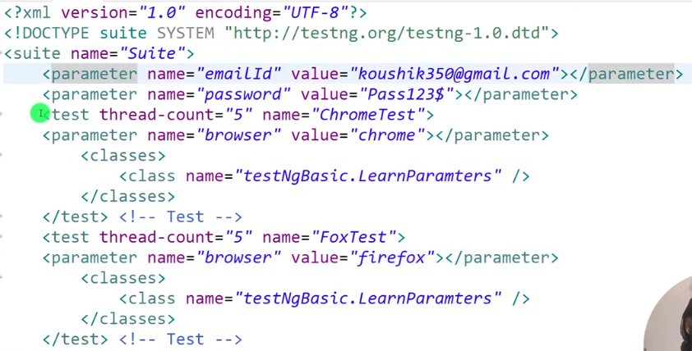

Parameter Suite level yum irukum. Test level yum irukum.

Parameter level = ithu parent mathiri parent la onnu forward pandrom na athu child kum reflect aghum.

Test level = But ithu Child level mathiri ithu antha child kulla madum act aghum.

**Video -54**

**Parameter ==> Oru data va XML la iruthu read pandrathuku..**

**Data provider ==> Multiple set of data va run pandrathuku.**

**@Dataprovider (name = “Login”)**

**Inke “name” ethuku na Oru class kulla multiple dataprovider use pannalam So, atha denote panna than namma name kodukuroom.**

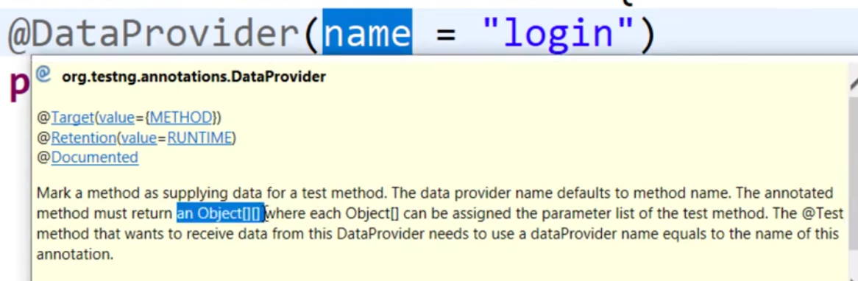**Provider voda return type == Object [][] of two dimension array..**

**So intha reason kaka than namma data va Two dimension array la store pandrom.**

Complie time error ah resolve panna error mela cursor ah vachu CTRL +1 panna resolve ayirum.

**Data provider = 2 in Details**

Namma kodukura Test Data innoru class iruntha eppudi edukurathu??????

Way -1

1. Nammaku thevaiyana Test data innoru class iruntha “Extends Keyword” use panni pannalam.
2. Appidi panna First Extends pandra class la irukura Annotation first execute aghum.
3. Athuku apparam than “@Test” annotation la irukura method implement aghum. @test annotation irukura class than run pannuvom..

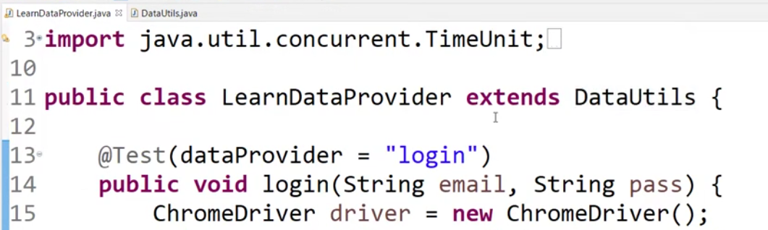

Way -2

1. Inheritence pannama dataprovider Attributes mathirye “dataproviderclass” nu iruku So athe use panni pannalam..
2. dataProviderClass = ClassName.class nu kodukkanum ippidi panna extends panna thevaiilai
3. **Ithu dataprovider attribute enga iruku anke use pannanum.**

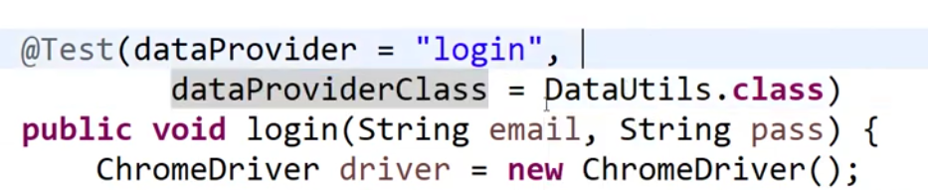

**“indices”**

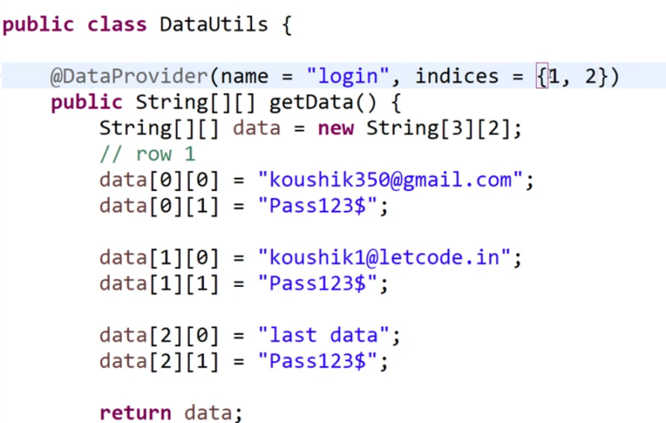

0

1

2

@DataProvider use pannom na athula irukura ellam datavum execute aghum. But Kuripitta data madum execute aganum na oru method iruku

“ indices” ={ithu array la value vankum 1, 2}

Then ithu index base panni run aghum.

So ippidi kodutha 1 , 2 position ullathu madum run aghum.

String [][] data = new String [3] [2];

//ithu String [3]= ndrathu "column"===== up to down

//String [2] = ndrathu "Row" denote pandrathu == left to right

{} === Its Generationaly Not metion the Size

[] === Its generally size is fixed…

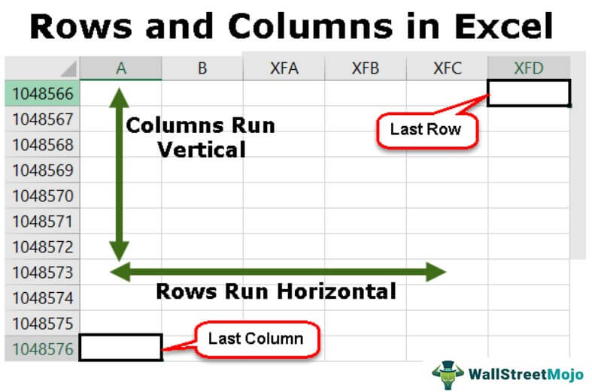

**Data provider = 3 [Parallel, isname Mandatory ? Parameter & DP]**

Munnadi 2 test case iruntha 1 by 1 than execute aghum. Two test case um onna parallel execute aganum na ena pandrathu… 1 test case oru browser layum innoru test case innoru browser layum run aghum.

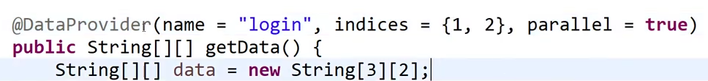

“Parallel”=== kudutha 2 test case me 2 browswer la onna execute aghum…

@Dataprovider === methods

1. Parallel
2. Name
3. Indices

But itha real time la use panna mattom.. Yean ithu epo work aghum na

Run pandra method kullaye chrome driver ah instance panna madum than ithu run aghum.. POM la driver vera engayo instance panni iruppom.

=============================================================================

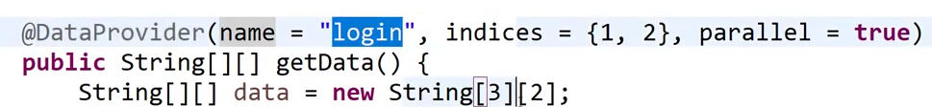

Dataprovider = “getdata” == method voda name kuda use pannalam.

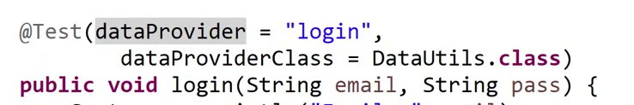

intha name than inke pass agura nala than getData() method la irunthu login method ku data pass aguthu…

Intha name mandatory ilai.. and @Dataprovider (name = “login”) intha Name remove pannom na And intha mathiri error varum.. TestNGException:

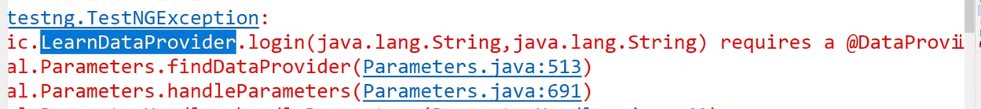

* @Test(dataProvider ) Remove panna kuda error varum..
* @Dataprovider ku pakkauthula irukura name = “login” remove pannidu getData ndra method name pass pannalam.

**Parameter and Dataprovider redume orey time la pass panna ena aghum?**

Dataprovider data High priority work aghum…

Data maathi use panna kuda Data provider Mismatch varum. ..

**Read Data from Excel**

**First video based on understanding the concepts**

Project Name = swagLap_test

package **utiles**;

public class ReadExcel

Read data from excel

Sheet1, Sheet2 …. nu multiple Sheet ah namma “Workbook nu solluvom”.

1. Read data from Excel

Dependency [Excel la irunthu data read pandrathuku ]

1. Apache POI === Ithu Old version excel file read pannnum.

2. Apache POI - OOXML === ithu New version excel file ah read pannum.

Mostly rendume Same version ah irukanum ilana sometime conflict varum.

XML file la Auto Alignment ku Ctrl + A ==> Ctrl + I

1. Pre- condition
2. Create an excel file with data

Excel file ah project kulla folder create panni pannalam…

Project -- rightclick -- Showin -- System Explorer ==Eclipse store agura folder open aghum. So ithula pooidu excel file onnu create pannigalam.

Location kodukum pothu = ./ nu kodutha ithu current project ah refer pannuthu..

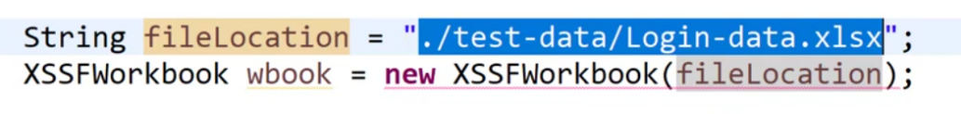

Intha mathiri error varum. Yean na inke file location ah pass pandrom.. but antha file anke irukalam. Ilamalum pogalaam. So, athunala compalie time error varum..

Itha **“*add throws exception”*** kuduthu resolve panniakalam.. ilana “***try catch”*** kodukanum.

1. Steps to implement

1. Locate the file

2. Locate the work book and sheet

3. Read the data from the cell (Rows & Column)

4. Close the resource

1. How to Read data from Excel
2. Read panna data va DataProvider ku eppudi pass pandrathu and @ Test ku eppudi pass pandrathu nu pappom

**Video -2**

Ithu excel la evalavu data irunthalum read panni edukum…

2 = cell irukum athu one data va delete panna

java.lang.NullPointerException: exception varumn

1 problem: Row and column voda data va Static ah manual ah nammalaye koduthom.. athe inke fix pandrom.. eppudi na..

* getLastRowNum()= ndrathu antha excel last enga edit pannamo athu varaikum ulla data va edukum..
* Ithu sheet ku next ah kodukanum..
* Ithu ”int” ah return pannum.
* Intha method first Row va count pannathu… (Header ah count pannathu)
* getLastRowNumn itha For loop la use pannum pothu i<=2a intha mathir “Equal” vachu kodukkanum apo than ithu method correct ah work aghum.

Nammaku Header um sernthu varanum na.. intha method ah use pannalam.

* Then itha Solve panna.. getPhyicalNumberofRow() a method iruku ithu Header un searthu count pannum..
* So intha method use pannum. Pothu for loop la i<2; koduntha pothum “Equal” thevai ilai
* Ithoda variable la for loop la pass pannanum.. panna Row voda work mudichathu. Then Cell voda work vera method iruku..

Data va read pannaum pothu +1

Data va Access pannum pothu tha -1

**Cell dynamic value pass panna innoru method iruku.**

Row ku getlastRowNum irukura mathiri Cell ku getlastRowNum method ilai.. So athunala

**Sheet.getRow(0);** Use panni Headar ku poidu.**. getlastCellsNum().** method ithula irunthu call panna varum..

Lastcellnum = J iteration ku pass pannidalam..

Then namma test data la Numeric value iruku na athu read pannum pothu exception varum

“illegalStateException” varum. So itha solve pannavum.. Then…….

**DataFormatter**S ku object create panni antha refrence variables moolama “formatCellvalue” call panni ithuku iteration moolama varra value ah ithula pass pannanom na

Read pandra ella datavum String ah convert ayidum.

**DataFormatter** entha data format ah irunthalum ithu String ah convert pannidum.

Why we should all test data covert to String?

Yean namma data va read panni @Test la pass pannum pothu sendkeys use panni than pass pannuvom @sendkeys ellam String madum than accept pannum. So ithuvum oru reason Dataformater ah use pandrathuku..

How to work TestNG Report and XML Report

TestNG Generate agura reports Show pandrathukana way…..

Window --- Show View --- Other --- type to TestNG ===> (Results of Running) open aghum.

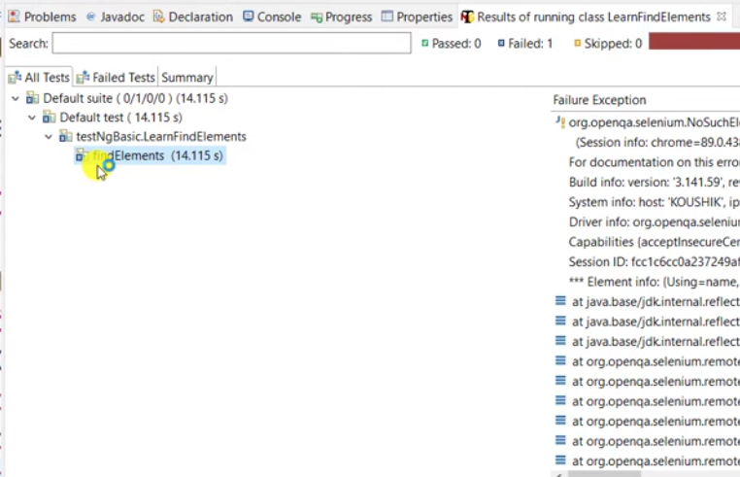

TestNG Color of error

Green color = pass

Blue color = fail

Yellow, Orange = Skip ana varum.

[Error voda line also TestNg report la kaadum]

Second Report]

Project right click ---> Showin --- system Explorer -- open the report folder.--- index.html (chrome symbol is there)

Then ithu varra report ellam next next running Override aghum.

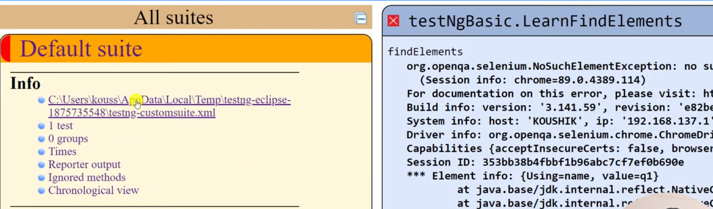

Ithe click pannale Oru XML file open aghum.

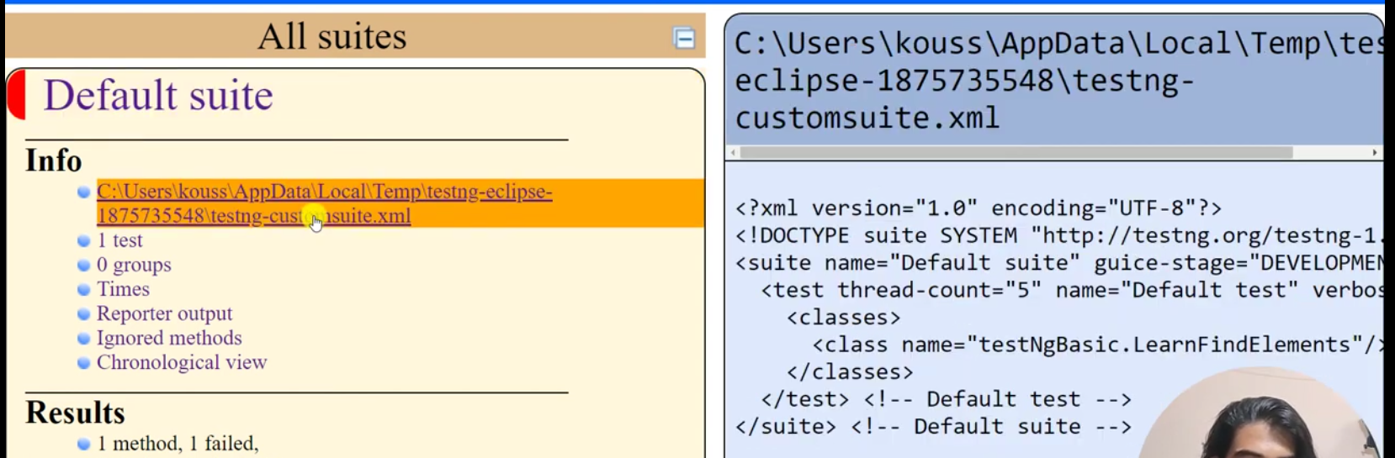

Learning ennana: TestNG epovume internala la oru XML file crate panni athoda than run aghum.

Oru class ah right click panni convert to TestNg kuduthu XML file la nammala create pannalum

Sari..

Direct ah class la vachu runas --- TestNg koduthalum TestNg epovume oru Xml file create panni athe base panni than run aghum.

TestNG Annotation

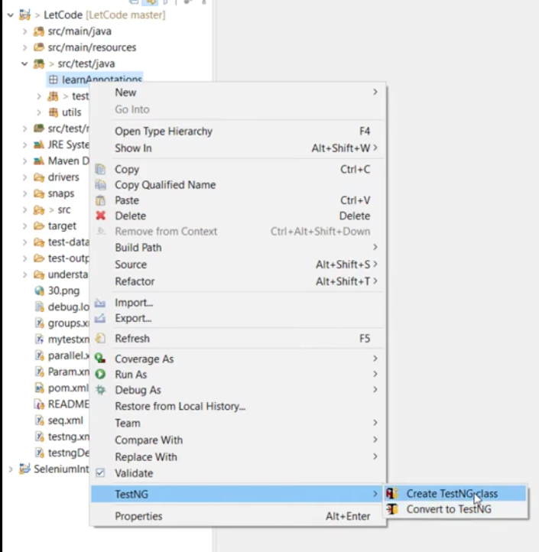So intha Model la TestNg class create panna porom .

Normala pandrathukum ithukum entha differentum kidaiyathu.

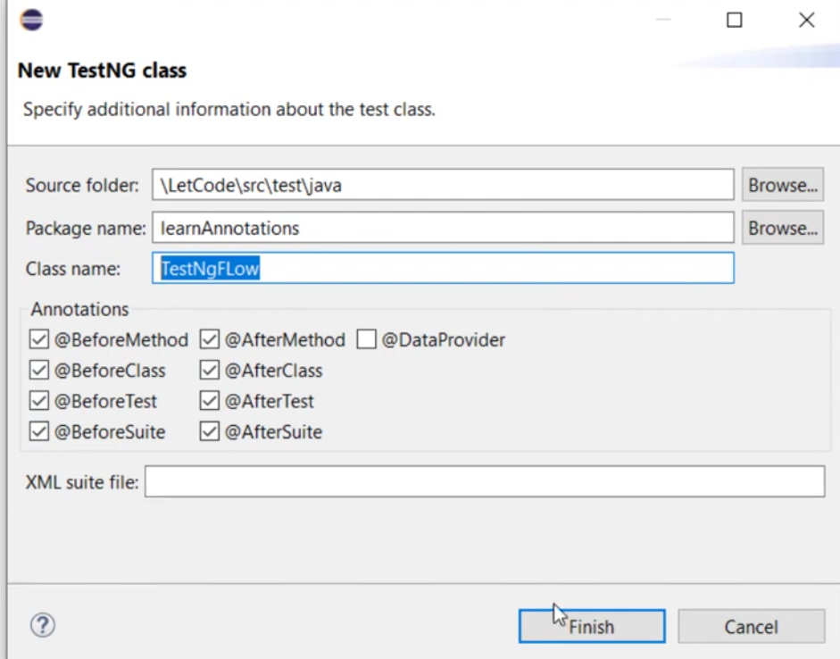

Dataprovider thavira ella Annotations select panni -- finish

Then class create aghum. Athula @test ndra innoru Annotation default ah create agi irukum.

Yean na TestNg @Test Annoatation ah vachu than run aghum.. Matha Annotation ellam optional than.

Mutiple @test orey class irukuna athu ASCII padi run aghum.

Inkea orey oru @Test than iruku.

@AfterTest work == Previous irukura ella Annotations Mudichurukkanu check pannum ithu than So ithu than Aftertest voda work.

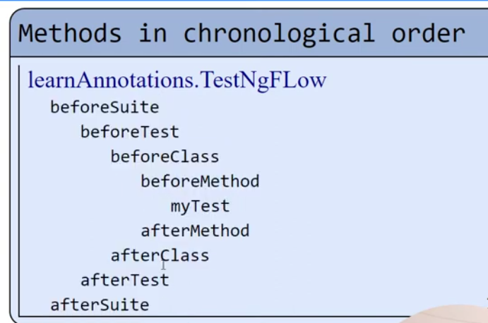

TestNG voda default Execution execution behaviour

Ithu Oru @Test iruntha ippidi nadakum.

@test Annotaion

Ithuve 2 @Test iruntha ena aghum nu pakkalam?

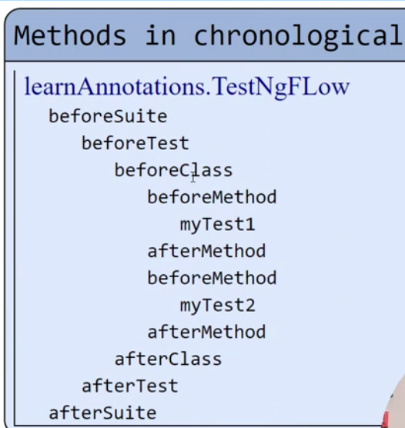

No.of @test ah depand panni BeforeMethod and After method execute aghum.

Matha Annotation ellam by default one time execute aghum.

Example ku: 10 @test iruntha 10 times Before method, after method execute aghum.

So intha hierarchy @Dataprovider use pannum pothu konjam change aghum.

Dataprodiver enga run aghum. Na === beforeclass kum beforemethod kum naduvula run aghum.